Key Knowledge
Wild Plants
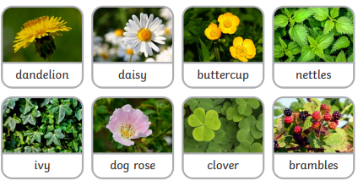
Garden Plants
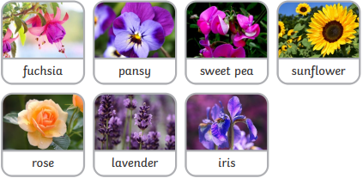
Key Vocabualary
wild plants | A wild plant seed grows where it falls. It  doesn’t need to be planted or cared for as  it grows.
garden plants | Garden plants are plants that people choose  to grow in their gardens.
weed | Weeds are wild plants that grow in places  where people don’t want them.
deciduous | A deciduous tree loses its leaves each year.
evergreen | An evergreen tree keeps its green leaves all  year round, even in the winter.
Year 1 Science – Plants
Year 3 Science – Forces and Magnets
Trees
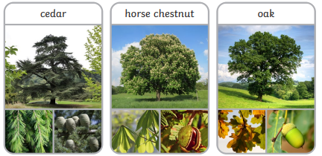

Key Vocabualary
roots | Roots take in water and nutrients from the  soil and keep the plant in the ground.
stem | The stem holds the plant up and carries the  water and nutrients from the roots to the leaves and flowers.
leaves | Leaves catch sunlight to help the plant to  make its own food.
flowers | Flowers attract insects and birds.
petals | Petals are the colourful part of the flower.
fruit | Fruit contains the plant’s seeds. Sometimes  humans try to grow fruit without seeds because it’s easier to eat.
seed | Seeds grow into new plants.
bulb | Bulbs grow into new plants.
Year 1 Science – Plants


