The Four Seasons
Autumn | Winter
September  October  November  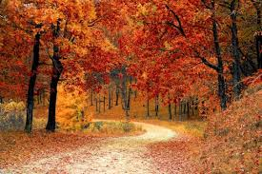 | December  January  February  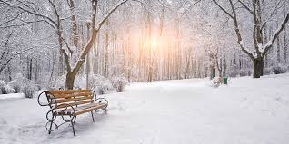
Spring | Summer
March  April  May  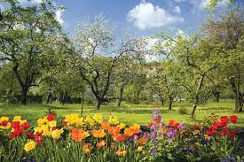 | June  July  August  
Key Vocabualary
seasons | In the UK, there are four seasons each year. They are spring, summer, autumn and winter.
autumn | In autumn, the temperature begins to get lower and it can be quite chilly and windy. It starts to get darker earlier in the day. Some animals get ready to hibernate and some types of trees lose their leaves.
winter | Winter is the coldest season of the year. It can be very rainy and windy and it might even snow. Not many flowers are in bloom during winter and lots of trees have lost all their leaves. Some animals hibernate during winter and many are less active than in the warmer months.
weather | The weather includes the emperature outside, how windy it is and rainfall (how much it rains). We can also describe cloud, snow and sun.
daylight | Daylight is when it is light outside. The amount of daylight changes with each season.
Year 1 Science – Seasonal Changes
Year 3 Science – Forces and Magnets
weather | 

