Key Knowledge
Alive | Once Alive | Never Alive
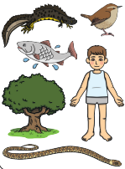 | 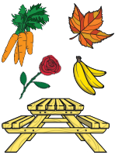 | 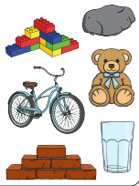
Key Vocabualary
living | Animals and plants are living things. Living things need to have their basic needs met to survive.
used to be alive | If something used to be alive (or was once alive), it means it used to be living but isn’t anymore. Now, it is dead
never  alive | Things made out of metal, glass, plastic or rock were never living because they did not move by themselves, grow or need food.
survive | To survive means to stay  alive.
basic  needs | Basic needs are the things  that living things need to  stay alive (water, food,  shelter).
Year 2 Science – Living Things and Their Habitats
Year 3 Science – Forces and Magnets
Basic Needs
All living things need:
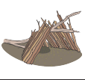 |  | 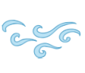 | 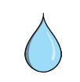
shelter | food | air | water

Key Vocabualary
habitat | A habitat is the natural place in which  something lives. A habitat provides living  things with everything they need to survive.
microhabitat | A microhabitat is a very small habitat that minibeasts live in.
depend | Living things in a habitat depend on each other to survive. This means they need each other to meet their basic needs.
food sources | Food sources are the things that living things eat.
food chains | A food chain shows how each animal gets its food. Food chains are one of the ways that living things depend on each other to stay alive.
Key Knowledge
Here are some examples of habitats:
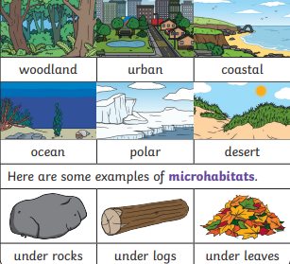
Year 2 Science – Living Things and Their Habitats

In a food chain, each arrow means ‘is eaten by’


