Key Knowledge
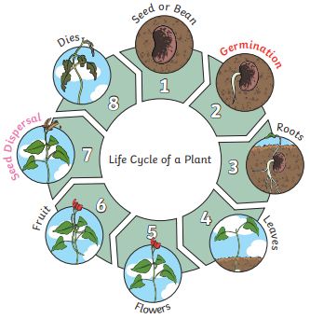
Key Vocabualary
germination | When the conditions are right, the seed soaks up water and swells, and the tiny new plant bursts out of its shell. This is called germination.
shoot | A shoot grows upwards from the seed or  plant to find sunlight.
seed dispersal | Seed dispersal is when the seeds move away from the parent plant. They can drop to the ground in the plant’s fruit or be moved by the wind or animals.
Year 2 Science – Plants
Year 3 Science – Forces and Magnets
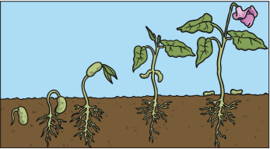

Key Vocabualary
What do plants need to grow well?
sunlight | All plants need light from the sun to grow well. Some plants need lots of sunlight. Some plants only need a little sunlight.
water | All plants need water to grow. Without  water, seeds and bulbs will not erminate.
temperature | Temperature is how warm or cold something or somewhere is. Some plants  like cooler temperatures and some like  warmer temperatures
nutrition | Food or nourishment. Plants make their  own food in their leaves using sunlight.
Key Knowledge
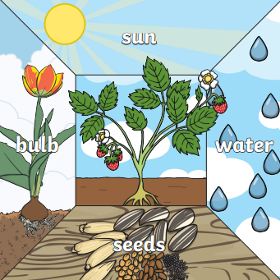
Year 2 Science – Plants



