Key Vocabualary
roots | These anchor the plant into the ground and absorb water and nutrients from the soil.
stem | This holds the plant up and carries water and nutrients from the soil to the leaves. A trunk is the stem of a tree.
leaves | These make food for the plant using sunlight and carbon dioxide from the air
flowers | These make seeds to grow into new plants. Their petals attractpollinators to the plant.
nutrients | These substances are needed by living things to grow and survive.  Plants get nutrients from the soil and also make their own food in their leaves.
evaporation | When a liquid turns into a gas.
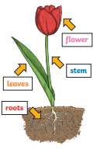
How Water Moves
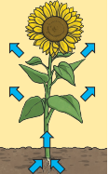
through a Plant
1. The roots absorb
water from the soil.
2. The stem transports water to the leaves.
3. Water evaporates
from the leaves.
4. This evaporation
causes more water to be sucked up the stem.

The water is sucked up the
stem like water being sucked up through a straw.
Year 3 Science – Plants
Year 3 Science – Forces and Magnets
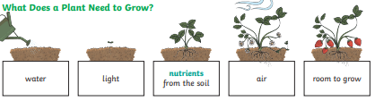
What do plants need to grow?

Key Vocabualary
fertilisation | When the male and female parts of the flower have mixed in order to make seeds for new plants.
petal | The brightly coloured part of the flower that attracts insects to pollinate the plant.
stamen | The male parts of the flower. The stamen is made up of the anther and the ilament. The filament’s job is to hold up the anther. The job of the anther is to make the pollen.
carpel (pistil) | The female parts of the flower. Made up of the stigma, style and ovary. The job of the style is to hold up the stigma. The stigma collects the pollen when a pollinator brushes by it. The ovary contains the ovules, which are the part of the flower that gets fertilised and eventually becomes the new seed.
sepal | Leaf-like structures that protect the flower and petals before they open out.
pollination | When pollen (a fine powdery substance produced by a flowering plant) is moved from the male anther of a flower to the female stigma.
pollinator | Animals or insects which carry pollen between plants. Examples include birds, bees and bats.
germination | When a seed starts to grow
seed dispersal | A method of moving the seeds away from the parent  plant so that the seeds have the best chance of survival.
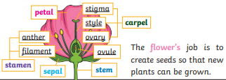

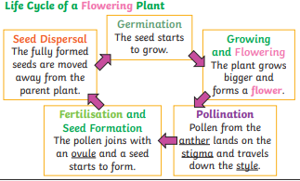
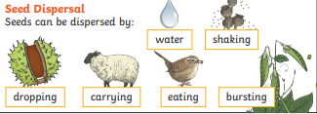
Year 3 Science – Plants

