Key Vocabulary
Year 3 Science – Rocks
Rock | Rock is a solid material made up  of one or more type of mineral.
Igneous | Igneous rocks are formed from magma or lava. These can be  extrusive or intrusive. Extrusive igneous rocks are formed above  the Earth’s surface, whereas intrusive igneous rocks are formed below the Earth’s surface.
sedimentary | Sedimentary rocks are formed when layers of sediment are pressed together over time. You  can often see these layers of sediment in the rock
metamorphic | Metamorphic rocks are formed when igneous or sedimentary rocks are exposed to extreme heat and pressure
minerals | Minerals are naturally occurring substances found in the Earth.  Most minerals have a crystal structure. Examples of minerals include quartz and gold

Key Knowledge
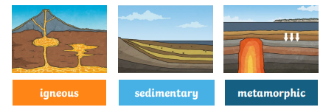
There are three types of naturally occuring rock.

Rock Properties
Words you might use to discuss the properties of rock include hard, soft, permeable, impermeable, density, texture, porous, grain size, durable

Examples of Rocks
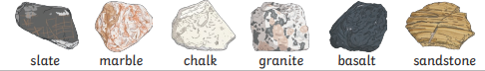

Examples of Soil
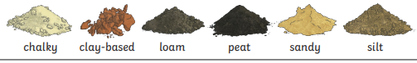

Key Vocabualary
permeable | A permeable material allows liquid to  pass through it.
impermeable | An impermeable material  does not allow liquid to pass through it
weathering | Weathering is the process whereby rocksand minerals break down into smaller pieces or wear away over time because of rain, wind, plants or animals
sediment | Sediment is a natural material carried to a new place by wind or water. It is made up of minerals, plants and tiny pieces of rock. Examples of sediment include sand and clay.
fossilisation | Fossilisation is the process through  which traces or remains of prehistoric living things become preserved
soil | Soil is the top layer of the Earth’s  surface. It provides nutrients and  support for plant life and it is made up of minerals (from broken-down rocks), air, water and organic matter (living things that are either dead or alive)
Types of Weathering
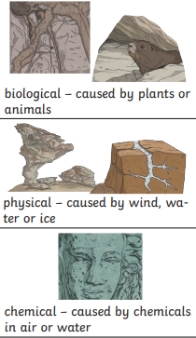
Fossillisation Process
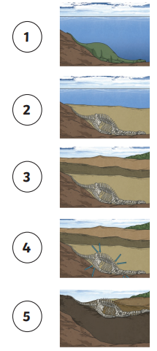
Year 3 Science – Rocks

