Key Vocabualary
Force | A force is a push or pull
Push | A push is a force that often moves an object further away
Pull | A pull is a force that often moves an object closer
Contact force | A contact force is a type of force that ocurs between two or more objects that are touching
Non-contact force | A non-contact force is a type of force that occurs between objects that are not touching
Friction | Friction is a type of contact force. IT occurs between two touching surfaces that are either trying to move or are already moving across each other
Moving on Rough Surface | Moving on Smooth Surface | Helpful Friction
Objects move differently on  different surfaces because of a force called friction.  Friction can be high on rough surfaces, causing objects to slow down more  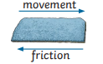  quickly. | An object will travel  further on a smooth  surface because there  are fewer bumps;  therefore, there is less  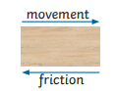  friction to slow it down. | Bumpy surfaces,  such as tyres or the  soles of shoes, help  to reduce the risk of  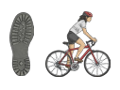  sliding or skidding.
Year 3 Science – Forces and Magnets
Contact Forces: Examples of puches and pulls
Pushes | Pulls
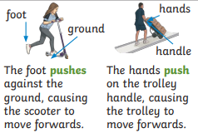 | 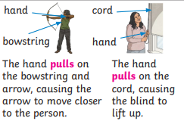

Year 3 Science – Forces and Magnets
Year 3 Science – Forces and Magnets
Key Vocabualary
Magnet | A magnet is a material that can  sometimes attract (pull) and sometimes repel (push) other magnetic materials
Metal | Metals are materials that are usually hard and shiny, such as iron and aluminium
Magnetic | If a material is magnetic, it can be attracted or repelled by a magnet
Magnetic force | A magnetic force is a  non-contact force produced by a magnet.
Pole | The poles of a magnet are the two points where the magnetic  force is strongest: the north pole and south pole.
attract | If a magnet attracts an object,  it causes the object to move  towards it.
repel | IF a magnet repels an object, it  causes the object to move away  from it
Magnetic Materials | Non-Magnetic Materials
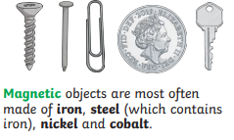 | 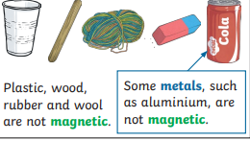

Like Pole Repel | Opposite Poles Attract
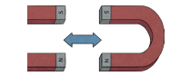 | 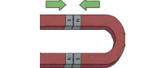
Names of Magnets


