Key Vocabualary
Year 4 Science – Animals including Humans
digest | Break down food so it can be used  by the body.
oesophagus | A muscular tube which moves food from the mouth to the stomach.
stomach | An organ in the digestive system where food is broken down with stomach acid and by being churned around
small intestine | Part of the intestine where nutrients are absorbed into the body.
large intestine | Part of the intestine where water is absorbed from remaining waste food. Faeces are formed in the large intestine.
rectum | Part of the digestive system where faeces are stored before leaving the body through the anus.
teeth | Hard structures in the mouth that help with biting and chewing food.
Key Knowledge
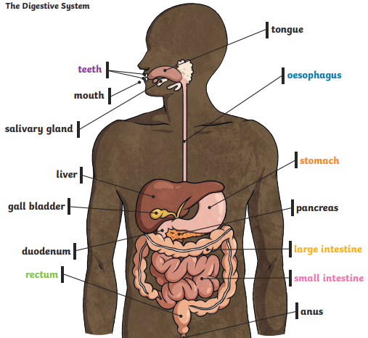

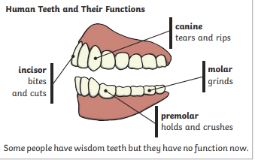

Key Vocabualary
Herbivore | An animal that eats plants
Carnivore | An animal that feeds on other animals
Omnivore | An animal that eats plants and animals.
Producer | An organism, such as a plant, that produces its own food
Predetor | An animal that hunts and eats other animals
Prey | An animal that gets hunted and eaten by another animal.
Year 4 Science – Animals including Humans
Key Knowledge


