Key Vocabualary
Year 4 Science – Living Things and Their Habitats
organism | ‘Organism’ is another way to refer to a living thing
habitat | A habitat is the specific area or place in which particular animals or plants may live
environment | The environment is the natural world, either as a whole or in a particular area.
species | A species is a group of living things that share enough similarities to be able to breed and produce young capable of breeding.
endangered  species | An endangered species is a species that is at risk of extinction.
extinct | ‘Extinct’ means that a species has no more members alive.
classification | Classification is the process of grouping living things according to their similarities
warm-blooded | ‘Warm-blooded’ refers to animals that are able to generate their own body heat

Vertebrate or Invertebrate?
Animals can be grouped into one of two main groups: vertebrates and invertebrates.

Vertebrate animals have a spine (also known as a backbone). The spine helps to hold the body upright, protects the spinal column and allows the body to move. Invertebrates do not have a spine.

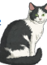
Vertebrates can be sorted into five main groups with their own characteristics.
Mammals - warm-blooded give birth to live young produce milk have hair or fur
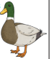
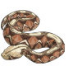
Birds - warm-blooded lay eggs have feathers have wings and a beak

Reptiles - cold-blooded lay eggs have scales
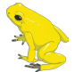
Amphibians - cold-blooded lay spawn often undergo metamorphosis
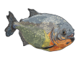
Fish -cold-blooded have scales lay spawn live in water

Invertebrates can be sorted into many different groups. Here are four of them.

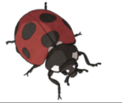
Arthropods - have an exoskeleton have jointed legs include insects, arachnids,crustaceans, myriapods
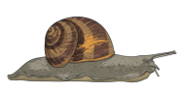
Molluscs - have a soft body with a head and a foot region often have a shell
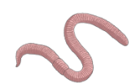
Annelids - have no legs have segmented bodies

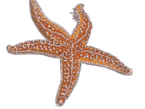
Echinoderms - have spiny or lumpy skin
live in the ocean
Year 4 Science – Living Things and Their HAbitats
Habitats
Plants and animals rely on their habitats to give them the conditions they need to live. Habitats can change, both naturally and due to human actions. These actions can
have positive and negative effects on the animals that live there.
Changes can make it easier or harder for living things to survive in the habitat. Organisms can become endangeredor even be made extinct due to changes in their habitats

Key Vocabualary
cold-blooded | ‘Cold-blooded’ refers to animals that are not able to generate their own body heat
vertebrate | A vertebrate is an animal that has a spine
invertebrate | An invertebrate is an animal that does not have a spine
characteristic | A characteristic is a particular  feature or quality that is specific to an individual or species
metamorphosis | Metamorphosis is the process by which certain animals completely change their  appearance and body structure.

