Key Vocabualary
Year 4 Science – Sound
vibration | A quick movement back and forth.
sound wave | Vibrations travelling from a  sound source
volume | The loudness of a sound.
amplitude | The size of a vibration.  A larger amplitude = a louder sound
pitch | How low or high a sound is

Key Knowledge
Sound is a type of energy. Sounds are created by vibrations. The louder the sound, the bigger the vibration

Pitch is a measure of how high or low a sound is. A whistle being blown creates a high-pitched sound. A rumble of thunder is an example of a
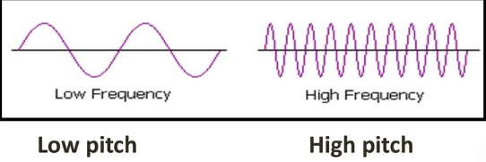
low-pitched sound.

The size of the vibration is called the amplitude .
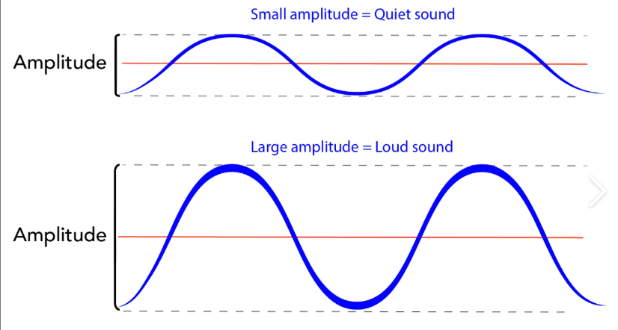
Louder sounds have a larger amplitude, and quieter sounds have a smaller amplitude.

You can change the pitch of a sound in different ways depending on the type of instrument you are playing.For example: xylophone - striking the smaller bars with the beater causes faster vibrations and so a higher pitched note.

Key Vocabualary
Year 4 Science – Sound
ear | An organ used for hearing
particles | Solids, liquids and gases are made of particles. They are so small we are  unable to see them
distance | A measurement of length between  two points
soundproof | To prevent sound from passing through
absorb sound | To take in sound energy. Absorbent  materials have the effect of  muffling sound.
vacuum | A space where there is nothing. There  are no particles in a vacuum
eardrum | A part of the ear which is a thin, tough layer of tissue that is stretched out like a drum skin. It separates the outer ear from the middle and inner ear. Sound waves make the eardrum vibrate

Key Knowledge

Sound can travel through solids, liquids and gases. Sound travels as a wave, vibrating the particles in the medium it is travelling in. Sound cannot travel through a vacuum.
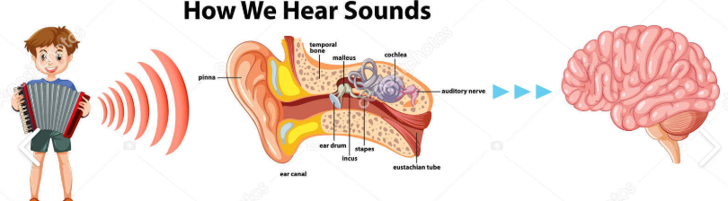

Sound energy can travel from particle to particle far
easier in a solid because the vibrating particles
are closer together than in other states of matter.

