Year 5 Science – Animals Including Humans
Key Knowledge
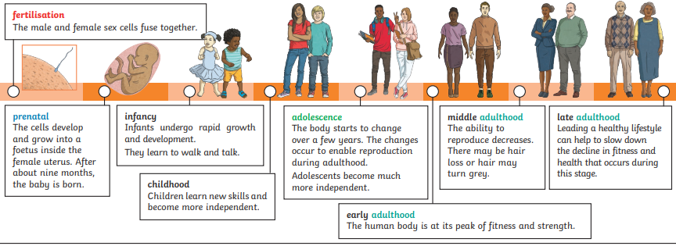

Key Vocabualary
fertilisation | The process of the male and female sex cells fusing together.
prenatal | The period of time before birth.
gestation | The process or time when prenatal development takes place before birth
reproduce | To produce young.
life cycle | The changes a living thing goes through, including reproduction.
Key Knowledge
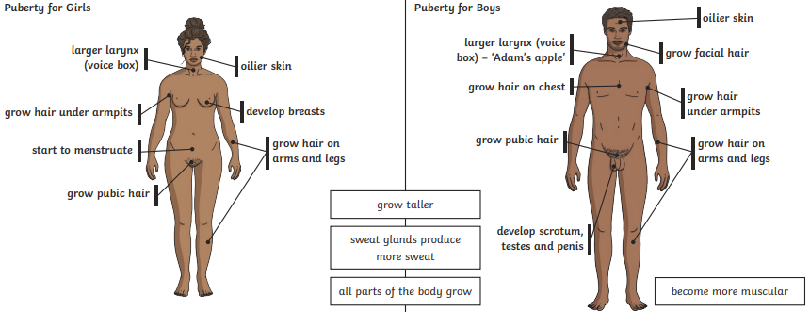
Year 5 Science – Animals Including Humans

Key Vocabualary
adolescence | The stage of development between childhood and adulthood
puberty | The period of physical change that happens during adolescence
menstruation | When the female body discharges the lining of the uterus. This happens approximately once a month.
adulthood | The stage of development when a human is fully grown and mature.
life expectancy | The length of time, on average, that a particular animal is expected to live.

