Key Vocabualary
material | The substance that something is made out of, e.g. wood, plastic, metal.
solid | One of the three states of matter. The particles in solids are very close together, meaning solids, such as wood and glass, hold their shape.
liquid | One of the three states of matter. A liquid can flow and take the shape of its container. Examples of liquids include water and milk.
gas | One of the three states of matter. The particles in gases are further apart than those in solids or liquids and they are free to move around. A gas fills its container, taking both the shape and the volume of the container. Examples of gases are oxygen and helium.
melting | The process of heating a solid until it changes into a liquid.
freezing | When a liquid cools and turns into a solid.
evaporating | When a liquid turns into a gas or vapour
condensing | When a gas, such as water vapour, cools and turns into a liquid.
Year 5 Science – Properties and Changes of Materials

Key Knowledge
Different materials are used for particular jobs based on their properties:
electrical conductivity, flexibility, ardness, insulators, magnetism, solubility, thermal conductivity, transparency

Change of State
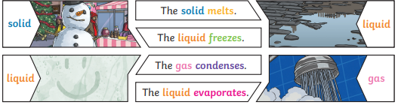
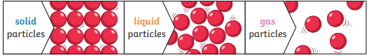

Year 5 Science – Properties and Changes of Materials

Key Vocabualary
conductor | A conductor is a material that  heat or electricity can easily  travel through
insulator | An insulator is a material that does  not let heat or electricity travel  through it
transparency | A transparent object lets light  through so the object can be looked  through, for example glass or  some plastic
Key Knowledge
Key Knowledge
Reversible changes, such as mixing and dissolving solids and liquids
together, can be reversed by:
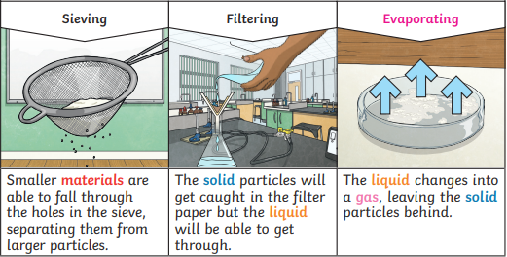

Disolving
A solution is made when solid particles are mixed with liquid particles.
Materials that will dissolve are known as soluble. Materials that won’t dissolve
are known as insoluble. A suspension is when theparticles don’t dissolve

Sugar is a soluable material.

Sand is an insoluable material.

Irreversible changes often result in a
new product being made from the old
materials (reactants). For example, burning
wood produces ash. Mixing vinegar and
milk produces casein plastic

