Key Vocabualary
offspring | The young animal or plant that is produced by the reproduction of that species.
inheritance | This is when characteristics are passed on to offspring from their parents.
variations | The differences between individuals within a species.
characteristics | The distinguishing features or qualities that are specific to a species.
adaptation | An adaptation is a trait (or characteristic) changing to increase a living thing’s chances of surviving and reproducing.
habitat | Refers to a specific area or place in which particular animals and plants can live.
environment | An environment contains many habitats and includes areas where there are both living and non- living things.
Year 6 Science – Evolution and Inheritance

Offspring:Animals and plants produce offspring that are similar but not identical to them.Offspring often look like their parents because features are passed on.

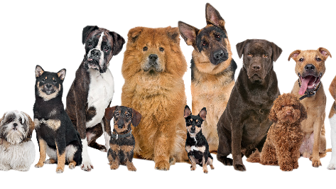
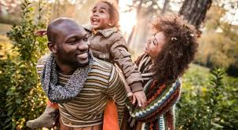
Variation: In the same way that there is variation between parents and their offspring, you can see variation within any species, even plants.

Adaptive Traits: Characteristics that are influenced by the environment the living things live in.These adaptations can develop as a result of many things, such as food and climate.

Inherited Traits: Eye colour is an example of an inherited trait, but so are things like hair colour, the shape of your earlobes and whether or not you can smell certain flowers.

Key Vocabualary
evolution | Adaptation over a very long time.
natural selection | The process where organisms thatare better adapted to theirenvironment tend to survive andproduce more offspring.
fossil | The remains or imprint of aprehistoric plant or animal,embedded in rock and preserved
adaptive traits | Genetic features that help a livingthing to survive.
inherited traits | These are traits you get from yourparents. Within a family, you willoften see similar traits, e.g. curlyhair.
Year 6 Science – Evolution and Inheritance

Fossils are the preserved remains, or partial remains, of ancient animals and plants. Fossils let scientists know how plants and animals used to look millions of years ago. This is proof that living things have evolved over time.

Evolution is the gradual process by which different kinds of living organism have developed from earlier forms over millions of years.Scientists have proof that living things are continuously evolving - even today!

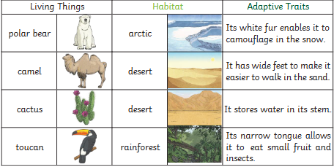

Natural Selection: Fossils of giraffes from millions of years agos how that they used to have shorter necks.They have gradually evolved through naturalselection to have longer necks so that they can reach the top leaves on taller trees.

