Mammals have hearts with four chambers. Notice how the blood that
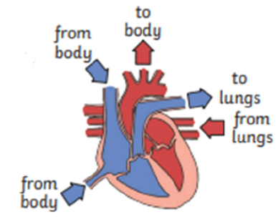
has come from the body is deoxygenated, and the blood that has come from the lungs is oxygenated
again. The blood isn’t actually red and blue: we just show it like
that on a diagram.
Year 6 Science – Animals Including Humans
Key Vocabualary
circulatory system | A system which includes the heart,  veins, arteries and blood transporting substances around the body.
heart | An organ which constantly pumps blood around the circulatory system.
blood vessels | The tube-like structures that carry blood through the tissues and organs. Veins, arteries and capillaries are the three types  of blood vessels
oxygenated blood | Oxygenated blood has more oxygen.  It is pumped from the heart to the rest of the body.
deoxygenated blood | Deoxygenated blood is blood where most of the oxygen has already been transferred to the rest of the body.

Capillaries are the smallest blood vessels in the body and it is here that the exchange of water, nutrients, oxygen and carbon dioxide takes place.

Arteries carry oxygenated lood away
from the heart.

Veins carry deoxygenated blood toward the heart.

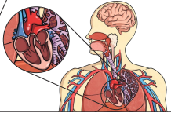
The heart pumps blood to the lungs to get oxygen.It then pumps this oxygenated bloodaround the body.

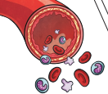
The liquid part of blood contains water and protein. This is called plasma.

Blood transports:
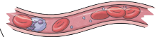
• gases (mostly oxygen and
carbon dioxide);
• nutrients (including water);
• waste products

Year 6 Science – Animals Including Humans
Key Vocabualary
drug | A substance containing natural or man-made chemicals that has an effect on your body when it enters your system
alcohol | A drug produced from grains, fruits or vegetables when they are put through a process called fermentation
nutrients | Substances that animals need to stay alive and healthy
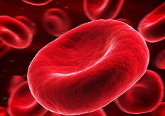
Plasma is liquid. The other parts of your blood are solid.
Red blood cells carry oxygen through your body.
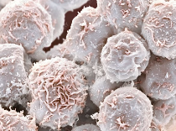
Platelets help you stop bleeding when you get hurt.
White blood cells fight infectionwhen you’re sick.

Regular exercise:
• strengthens muscles including
the heart muscle;
• improves circulation;
• increases the amount of oxygen around the body;
• releases brain chemicals which help you feel calm and relaxed;
• helps you sleep more easily;
• strengthens bones.
It can even help to stop us from
getting ill

Drugs, alcohol and smoking have negative effects on the body.
A healthy diet involves eating the right types of nutrients in the right amounts

