Key Vocabualary
microorganism | A microorganism is an organism that can only be seen using a microscope.
species | A species is a group of organisms with shared characteristics that can  reproduce to produce fertile offspring.
characteristics | A characteristic is a particular feature or quality that is specific to an  individual, species or group.
classification | Classification is the process  of grouping living things according to their similarities.
classification key | A classification key is a set of questions used to identify and group living things. They are usually based on an organism’s physical  characteristics.
organism | ‘Organism’ is another way to  refer to a living thing
Classification
In the 1700s, Swedish scientist Carl Linnaeus published a system for classifying living things based on their observable characteristics, known as
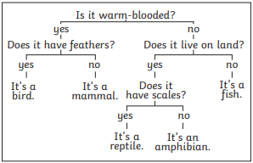
the Linnaean System. An adapted version of this system is still used today.

Year 6 Science – Living Things and Their Habitats

Flowering and Non-Flowering Plant
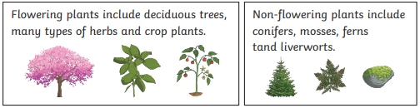
Plants can be sorted based on whether they are flowering or non-flowering. Flowering plants use flowers to produce seeds at some point in their life cycle, whereas non-flowering plants reproduce using cones, spores and fragmentation.

Year 6 Science – Living Things and Their Habitats

Microrganisms
Microorganisms are microscopic organisms
that can be found almost everywhere on Earth –
including inside our bodies
Vertebrate Groups
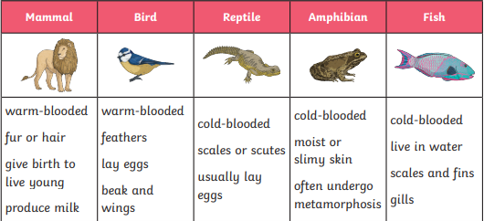

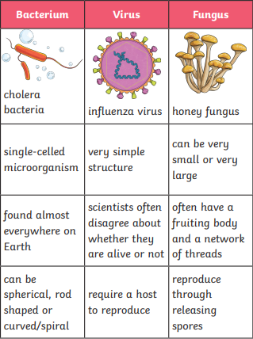

Some Invetebrate Groups


